**Airplane mode of Wireless WAN automated testing**

**Version 1.0**

**Version History**

|  |  |  |  |
| --- | --- | --- | --- |
| **Version** | **Date** | **Handled by** | **Comments** |
| V1.0 | 10-June-2019 | ZL Chen | First version release. |
| V2.0 | 12-June-2019 | ZL Chen | Second version release for WWAN. |

Precondition Setting:

Please make sure the DUT is connected to the internet.

* Install the adb interface driver
  + Please refer to the “ADB interface driver.pdf” attachment.

(\automation\sop\other\ADB interface driver.pdf)

* Install the Python 3.6.8.
  + Please refer to the “Python 3.6.8 installation.pdf” attachment.

(\automation\sop\other\Python 3.6.8 installation.pdf)

* Install the third party library.
  + Double click the “Envir_Install.exe” under the installer folder.

(\automation\installer\Envir_Install.exe)

Please follow the implement as below:

Block Diagram:

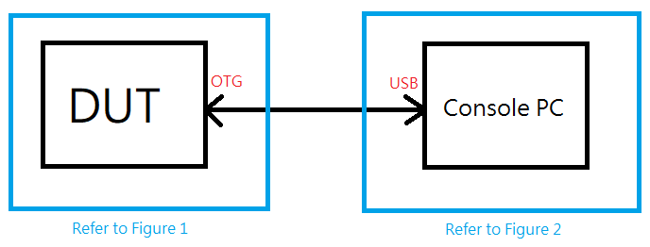

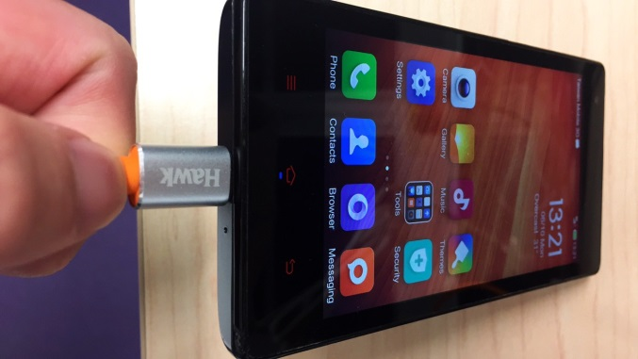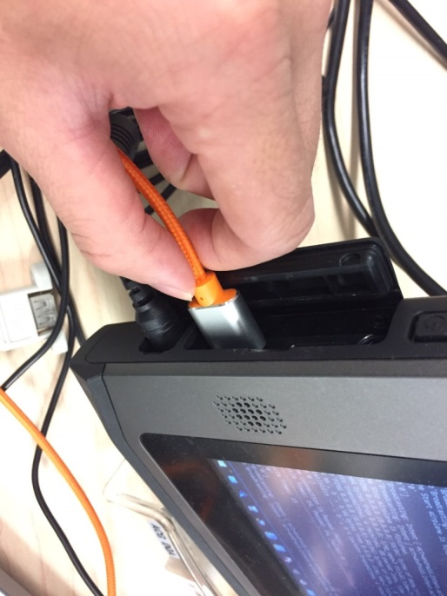

Figure 1 Figure 2

Step 1:

Please make sure the 3G is connecting to the repeater. (Figure 1)

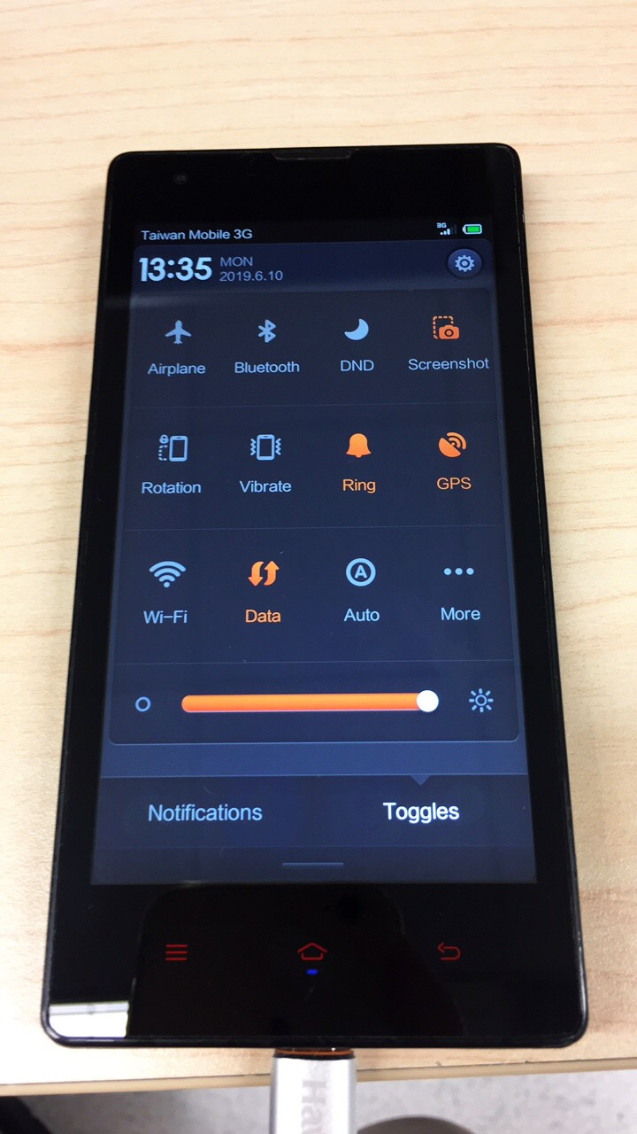

Step 2:

Please shutdown the Wi-Fi, make sure the 3G connection is finished.(Figure 1)

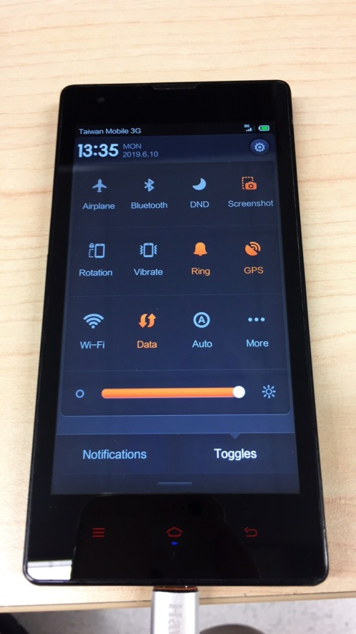

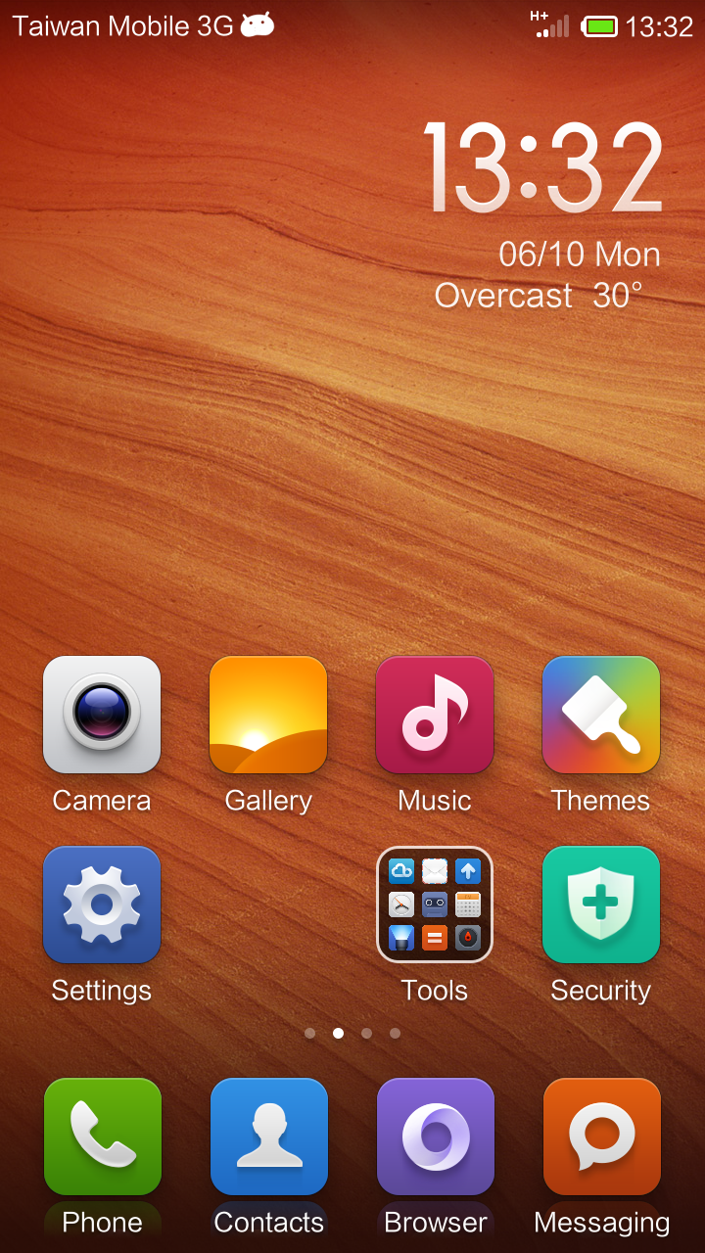

Step 3:

Please copy the airplane_wwan folder of the suite to the device’s desktop. (Figure 2)

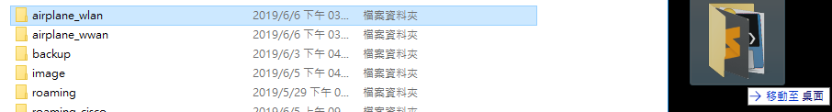

Make sure the adb.exe should be worked, so please input the window command as below: (Figure 2)

Command: “adb.exe kill-server” and “adb.exe start-server”

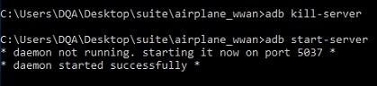

Command: “adb.exe devices”

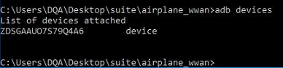

Make sure the “Allow USB debugging” alert is pop up on the DUT window. (Figure 1)

Please check the “Always allow from this computer” box, then tap the “OK” button.

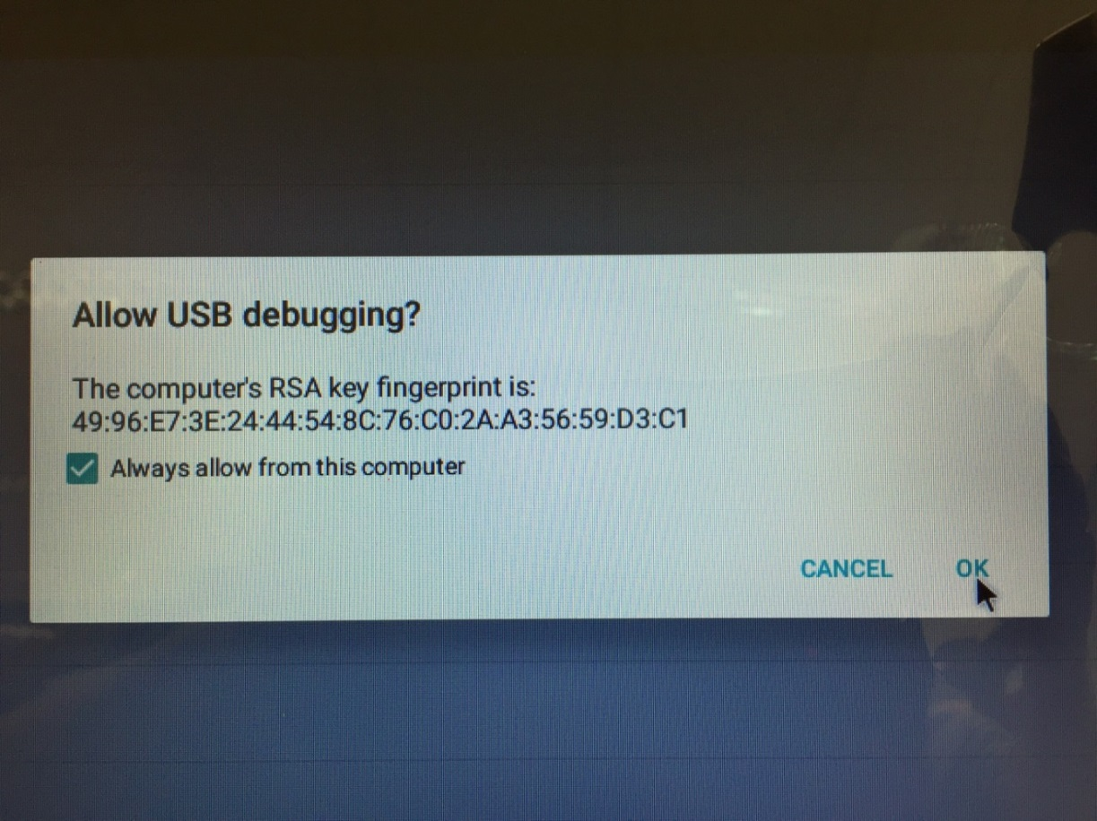

Implement the airplane_wlan.exe under the “\airplane_wwan\” folder. (Figure 2)

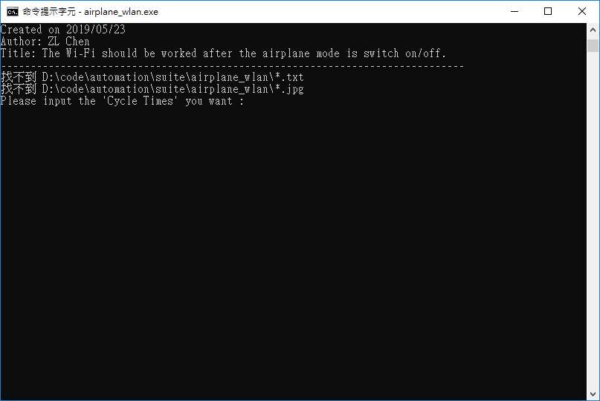

Step 4:

Please input the “Cycle Times” you want. (Ex: 1), and then tap the “Enter”. (Figure 2)

The program is start running.

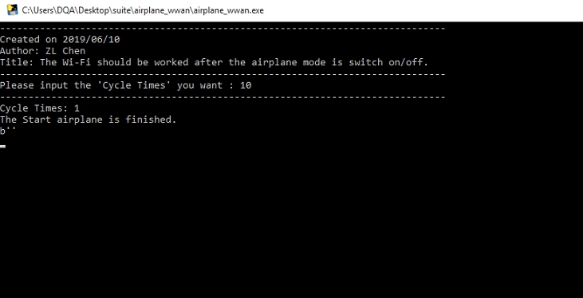

Step 5:

When the program is completed, the windows should be closed.

You can see the log under the “\airplane_wwan\” folder as below: (Figure 2)

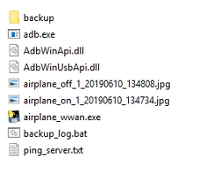

* ping_server.txt is ping log.

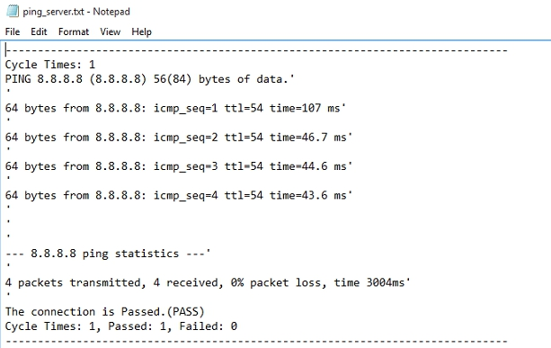

The Total Cycle Times is 1, Passed is 1 and Failed is 0.

* airplane_off_1_20190610_134808.jpg is airplane switch off by screenshot.

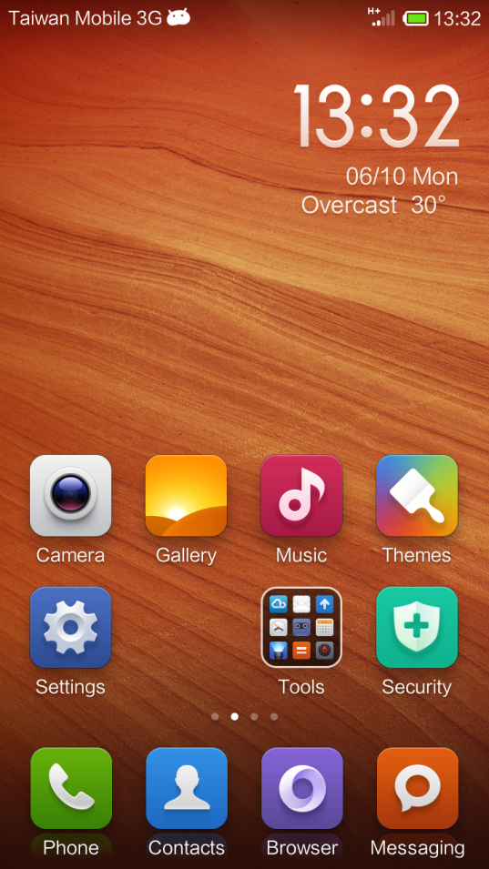

* airplane_on_1_20190610_134734.jpg is airplane switch on by screenshot.

